**CHAPTER 1**

**INTRODUCTION**

**1.1 Background**

A website is a collection of related web pages, including multimedia content, typically identified with a common domain name, and published on at least one web server. A school website is a website designed, built and maintained by school or for a school. The purpose of the website is to provide a visitor friendly web pages that are easy to use and provides sufficient information about the school. It provides information on homework and class assignments, displaying exam schedule and results, displaying student project, providing information about holidays, providing calendar and its events, provides forum for teachers, administration, students and parents to exchange information.

Many school websites share certain characteristics, and some educators have developed guidelines to help schools create the best and most useful websites they can. A school website is a communication tool between the school and the community; however, its reach can extend beyond country, states lines. A school website may be used by many demographics groups such as staff/administration, parents, student, community as well as former students and alumni. Even across state lines a school website can connect groups of its demographics such as the alumni now living cross country looking for information on the next reunion.

**1.2 Motivation**

We were motivated by the basic problem faced by the students is inconvenience of visiting school for each and every requirement such as fee structure, notice, announcement, events etc. for such detail student is required to visit school which is really time consuming and the students have to travel for a long distance for general formalities. When school passes a notice it is necessary for each to go through it, in such cases it is difficult for school to ensure that every student got the notice as students who are absent may miss it. All the notices and announcements provided by school should reach every student. So the school website gives flexibility to students so that they can obtain the information right from the desk.

The website will be user friendly and it doesn’t require any training or extra effort to understand it properly. It provides a number of facilities on a click. This system is aimed to run smoothly by the school management. In order to achieve this the website will contain many features.

**1.3 Statement of Problems**

School websites usually in our country are generally under developed. Due to lack of expertise among non-teaching staff is the major factor. Many school has not given priority to their websites due to the lack of budget and the time. Sometimes there are skilled persons among the staff but due to the lack of investment of their time the website is not properly developed. So by investing a little bit of more time we try to make a better interactive and dynamic website.

**1.4 Objectives**

The main objectives of the proposed project can be enumerated as follows:

1. To design and develop a school website by using HTML, PHP, JavaScript and CSS.

**1.5 Application**

Some of the application of our project are listed below:-

1. This website is user-friendly and can be easily maintained by the non-expertise.
2. An affordable website for under-developed school.

**CHAPTER 2**

**LITERATURE REVIEW**

Proper design has become a critical element needed to engage website and mobile application users. Now a day, educational institute also need a user friendly simple and best website. For example GEMS school website. It highlight the school name , logo, photo , beautiful Animation and eye catching color combination of text and bar. In the top of the website it shows the school name and logo. Where school name in white color and background color in dark blue and logo place in front of the school name. Then below the title horizontal navigation bar contain attribute like Home, about us, information, contact, clubs and ECA and download. The simple and best website contain the less text and more picture or Animation. The body of the GEMS school contain the beautiful design of slid of photo and little about school history. Then at the bottom it consist founder director’s Message and footer of the website. [3]

This website is the online tools that will engage parents, students, teacher and staff of the school. Teachers and students can use it to share documents. We can even use it to create an internal intranet site to more effectively share information with different faculty and other staff.

The website of Galaxy Public School is simple and well managed website that provides the good information about the school. This website provides the information of admission, activities and the upcoming events of the school. This website also provides the school calendar. Overall, it is well managed and reactive website. [4]

Little Angels’ School has a website that can be easily accessed for own reason. Unlike other school’s website, this website has the background color of the uniform of the student. That also makes this website more attractive and interesting. [6]

**CHAPTER 3**

**PROJECT MANAGEMENT**

**3.1 Work breakdown:**

While developing this website we had divided the work for each team members.

1. Anjan Shrestha (730308)

* Analysis
* Design
* Coding
* Testing

2. Nirav Shrestha (730323)

* Analysis
* Design
* Coding
* Testing

3. Prakash Budhathoki (730325)

* Analysis
* Design
* Coding
* Documentation

4. Siddhant Shrestha

* Analysis
* Design
* Coding
* Documentation

**3.2 Feasibility study**

There have been previous attempts successful and unsuccessful in implementing this kind of school website. Some of the prominent websites are GEMS School website, Galaxy School Website, St Xavier’s Website etc. These websites are aesthetic and featureful, its design simple and attractive and with features like online forum, news portal, online result publication etc.

|  |  |  |  |  |  |  |  |  |  |  |  |  |  |  |  |  |  |
| --- | --- | --- | --- | --- | --- | --- | --- | --- | --- | --- | --- | --- | --- | --- | --- | --- | --- |
| Tasks | Duration  [weeks] | February | | | | March | | | | April | | | | May | | | |
| 1 st | 2 nd | 3 rd | 4 th | 1 st | 2 nd | 3 rd | 4 th | 1 st | 2 nd | 3 rd | 4 th | 1 st | 2 nd | 3 rd | 4 th | |
| Gathering of requirements | 5 weeks |  | | | |  | | | |  | | | |  | | | |
| Research and analysis | 2 weeks |  | | | |  | | | |  | | | |  | | | |
| Website design | 4 weeks |  | | | |  | | | |  | | | |  | | | |
| Website coding | 7 weeks |  | | | |  | | | |  | | | |  | | | |
| Debugging and testing | 3 weeks |  | | | |  | | | |  | | | |  | | | |
| Documentation | 7 weeks |  | | | |  | | | |  | | | |  | | | |

**3.3 Project Scheduling**

**CHAPTER 4**

**METHODOLOGY**

**4.1 Block Diagram**

Home

Result

Contact Us

Notice

Log in

Notification

Events

Admin

Register

Student

Holidays

Delete

**Figure 4.1: Block Diagram of School Website**

**4.2 Tools used**

* **HTML**
* **CSS**
* **JAVASCRIPT**
* **PHP**
* **Platform Specification**
* Windows Operating system.
* Mozilla Firefox, Google chrome, Opera, Internet Explorer.
* Xampp /Wamp Server.

**4.3 Use Case Diagram**

Jjlkk

**dfsdfd**

student

admin

parent

<<extends>>

**y**

teacher

**Figure 4.2: Use Case Diagram**

**4.4 E.R Diagram**

System

manages

has

Admin

User

ISA

Visitor

Staff

Student

has

has

Login

**Figure 4.3: E.R Diagram**

**CHAPTER 5**

**RESULT AND DISCUSSION**

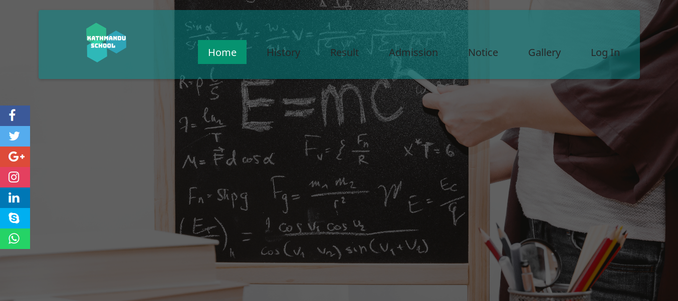

**Figure 5.1 Homepage**

The above screenshot shows the homepage of our website. As shown above there are various options i.e. Result, Admission for showing results and online admission etc.

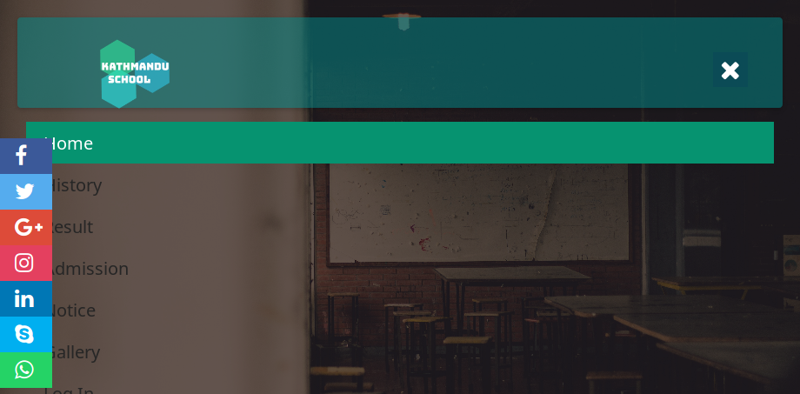

**Figure 5.2 Responsive Homepage**

The above screenshot shows the responsive homepage for smaller screen.

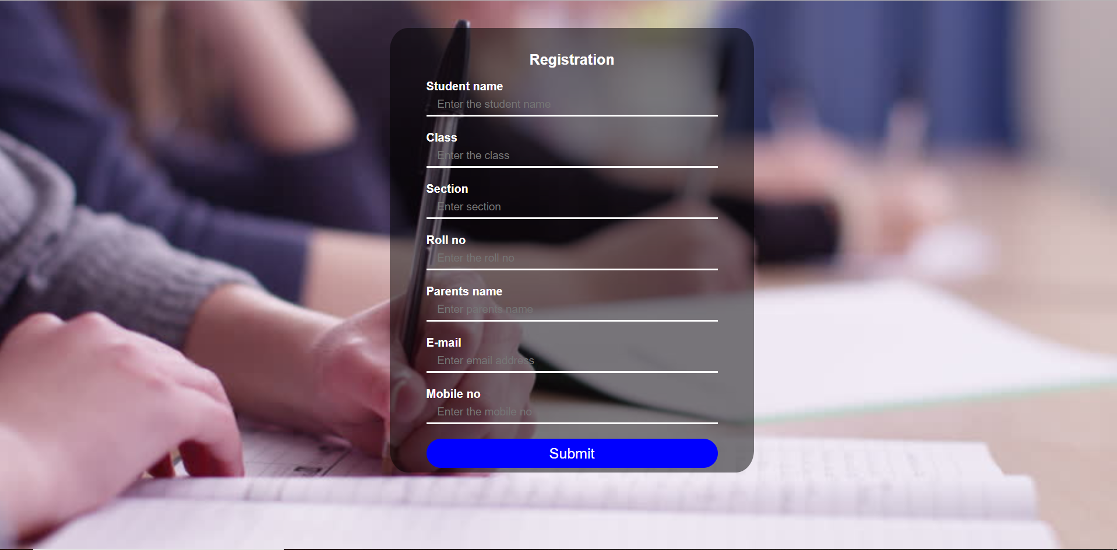

**Figure 5.3 Email Notification Registration**

The above screenshot shows the registration page for the email notification service. Users can provide their email id and they will be notified about the various events, notice about the school.

**Figure 5.4 Registration Deletion**

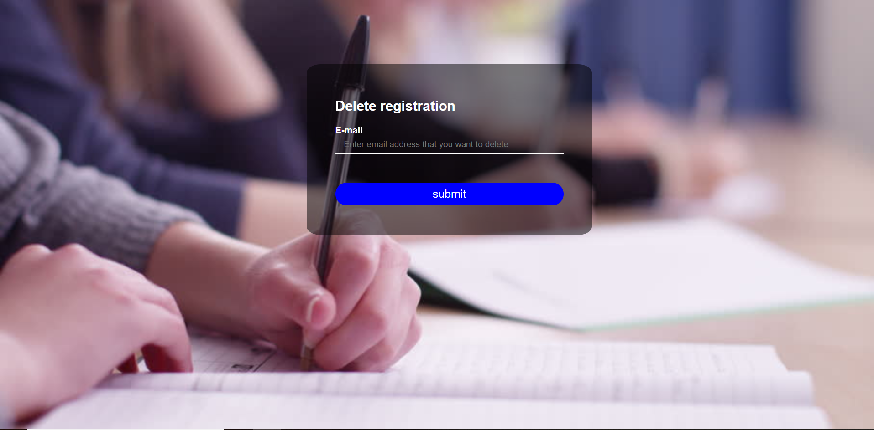

The above screenshot shows the deletion page for the email notification service through which users can prompt the admin to unsubscribe them from the email notification service.

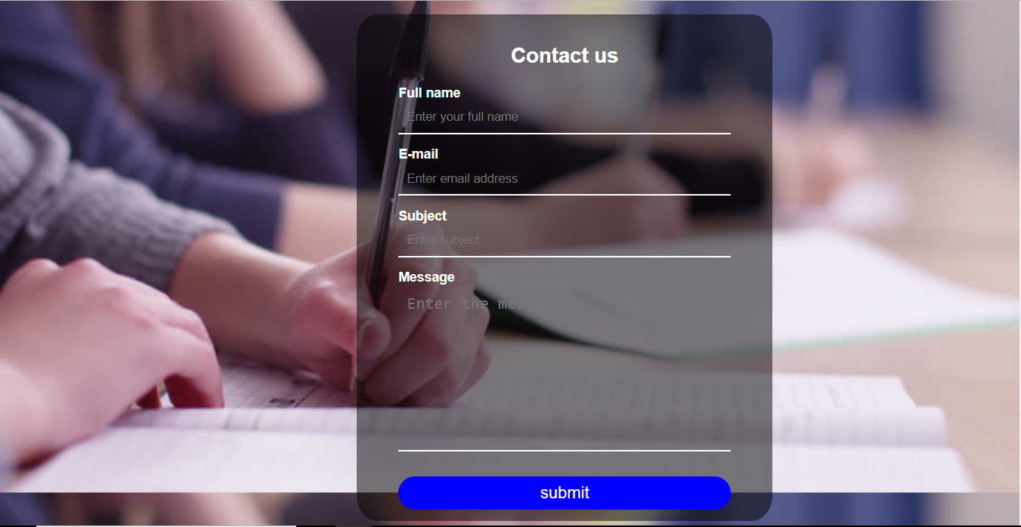

**Figure 5.5 Contact Us**

The above screenshot shows the contact page for the email notification service through which users can message the admin about various subjects. 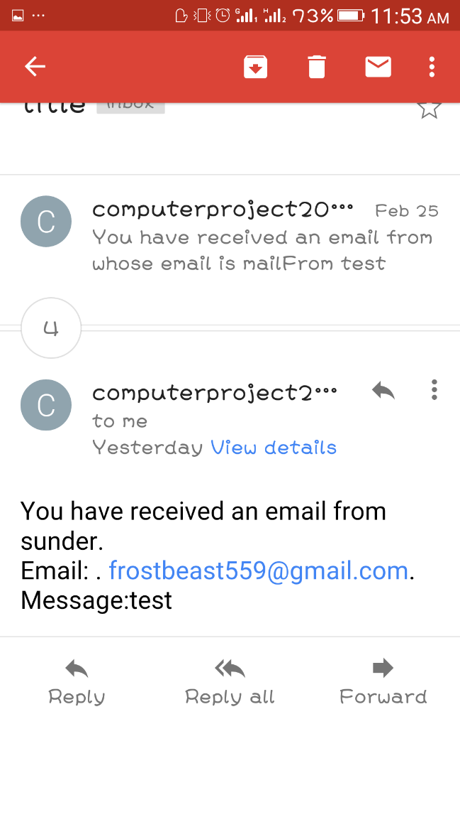 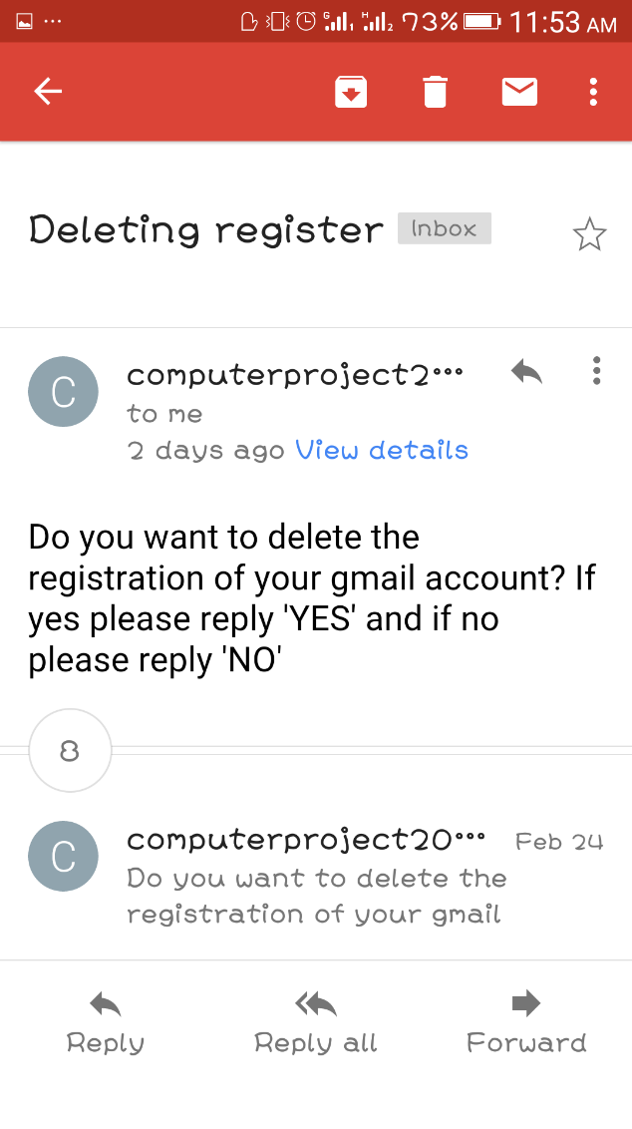

**Figure 5.6 Email Confirmation of Notification Service**

The above screenshots shows the samples of the emails sent by the email notification service.

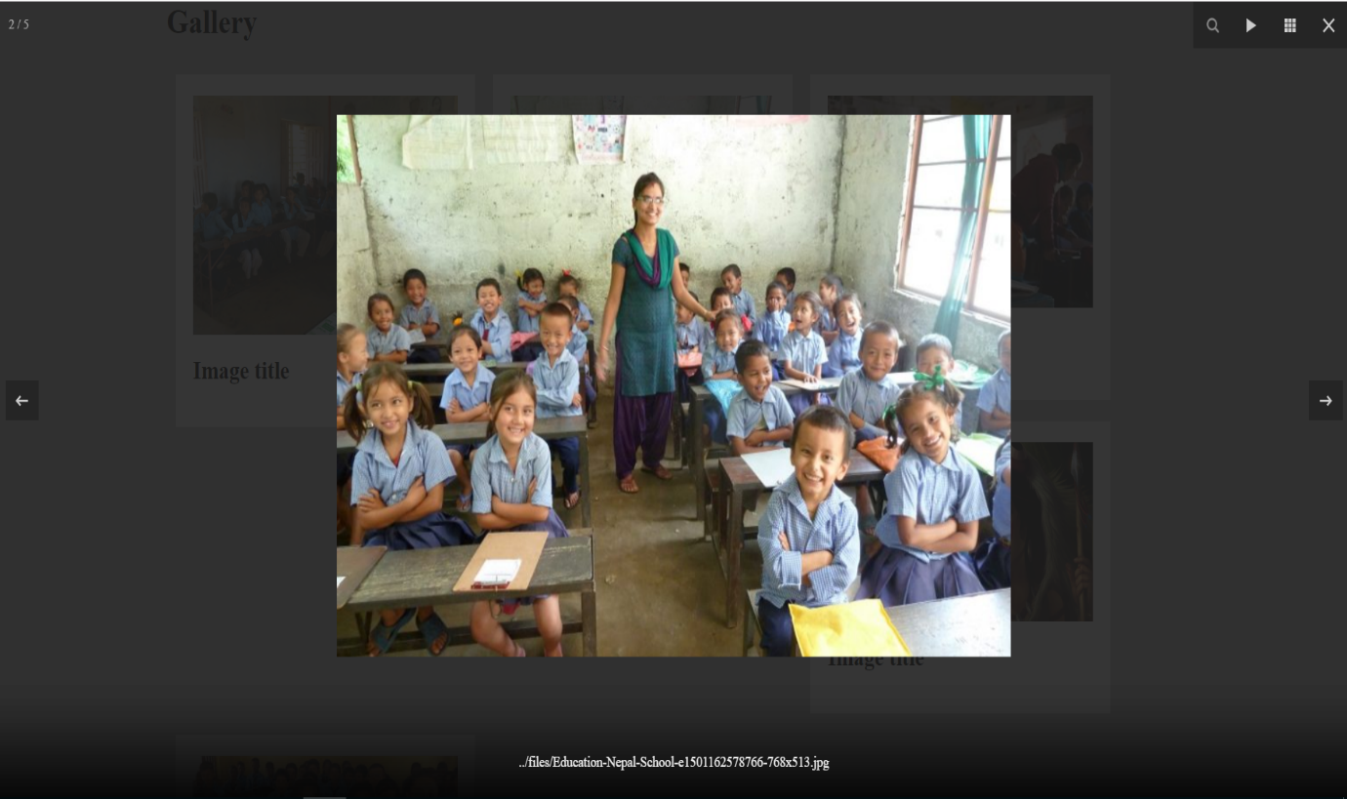

**Figure 5.7 Gallery**

The above screenshot shows the gallery of the website with features like zoom capability, slide show etc.

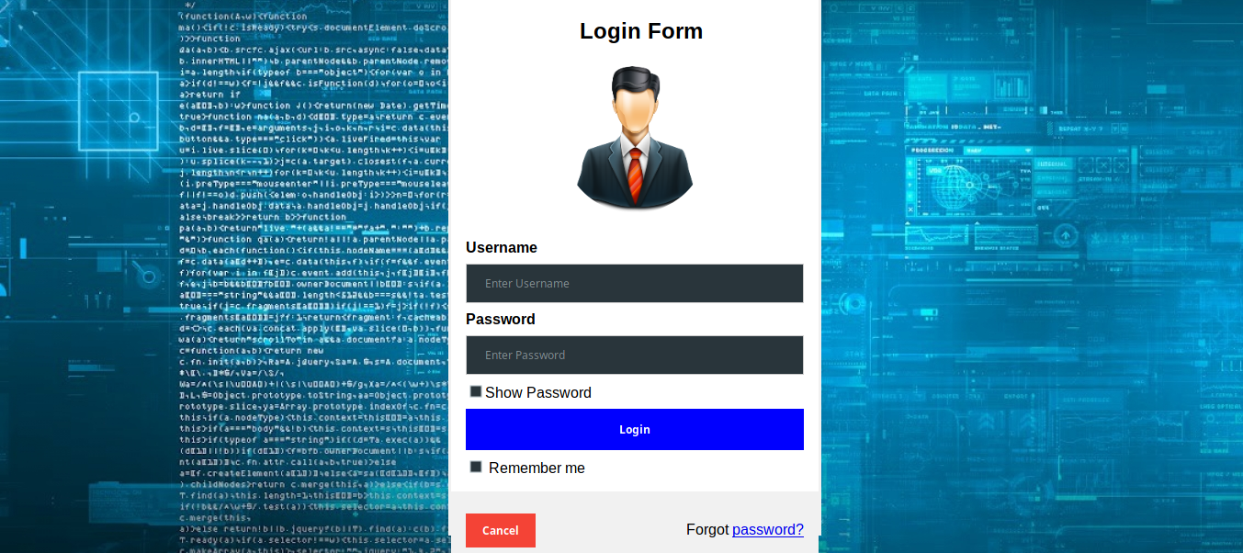

**Figure 5.8 Admin Login Page**

The above screenshot shows the login page for the website for admin.

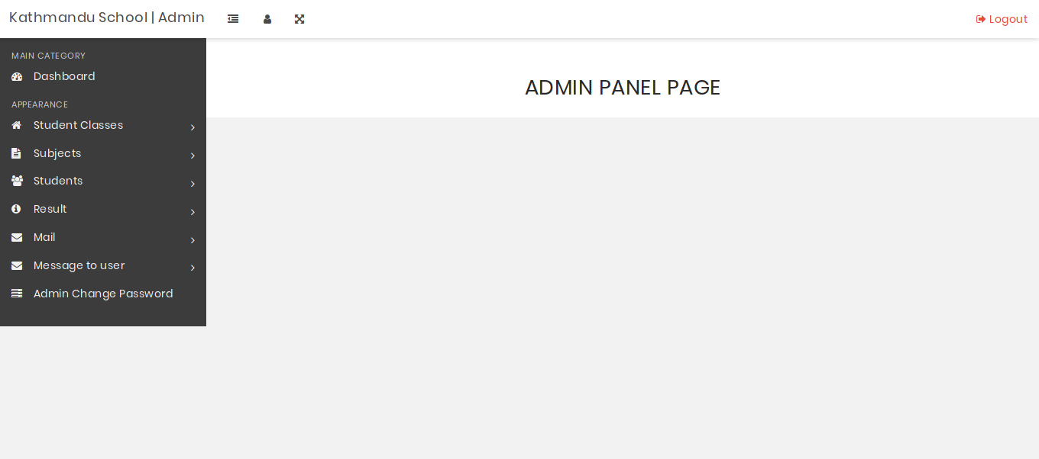

**Fig 5.9 Admin Panel**

The above screenshot shows the dashboard for the admin panel.

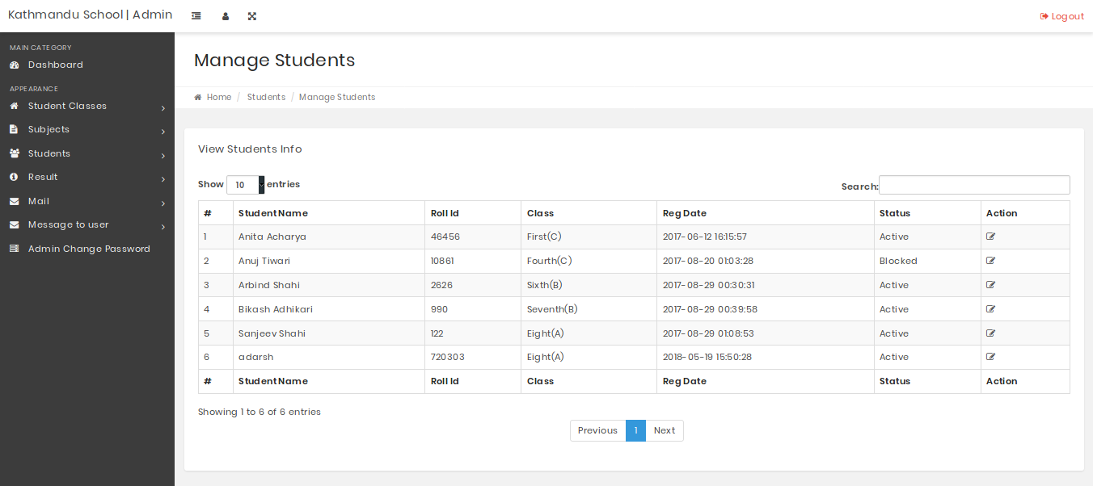

**Fig 5.10 Manage Students Page**

The above screenshot shows the students page through which we can manage all the enlisted students after adding them through the Add Students Page.

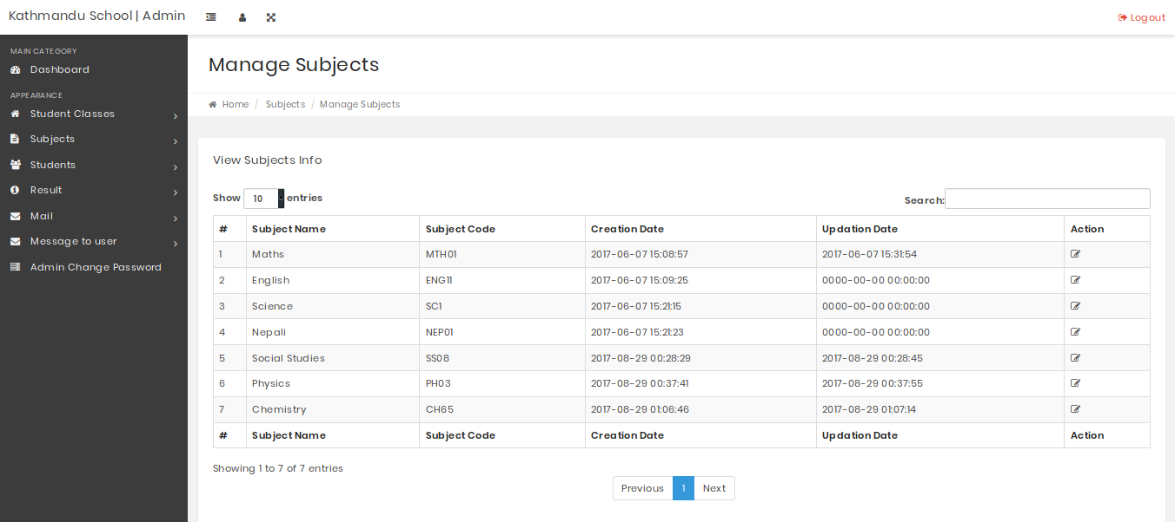

**Fig 5.11 Manage Subjects Page**

The above screenshot shows the subject page through which we can manage all the available subjects for the school.

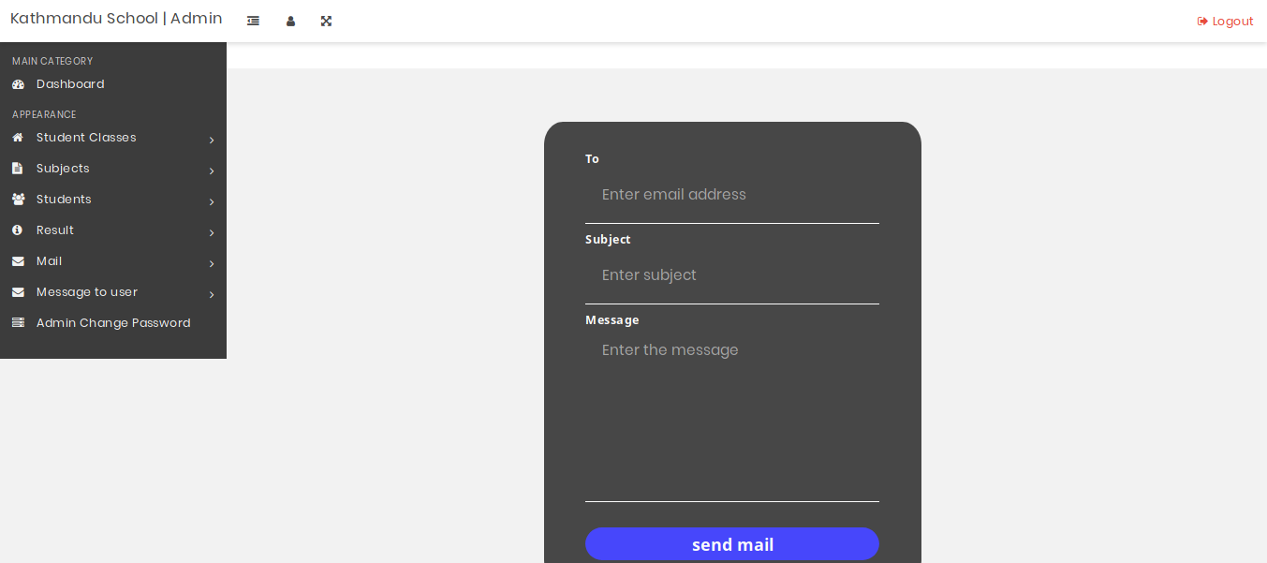

**Fig 5.12 Mailing Service**

The above screenshot shows the mailing page through which we can send messages to all the users of the email notification service.

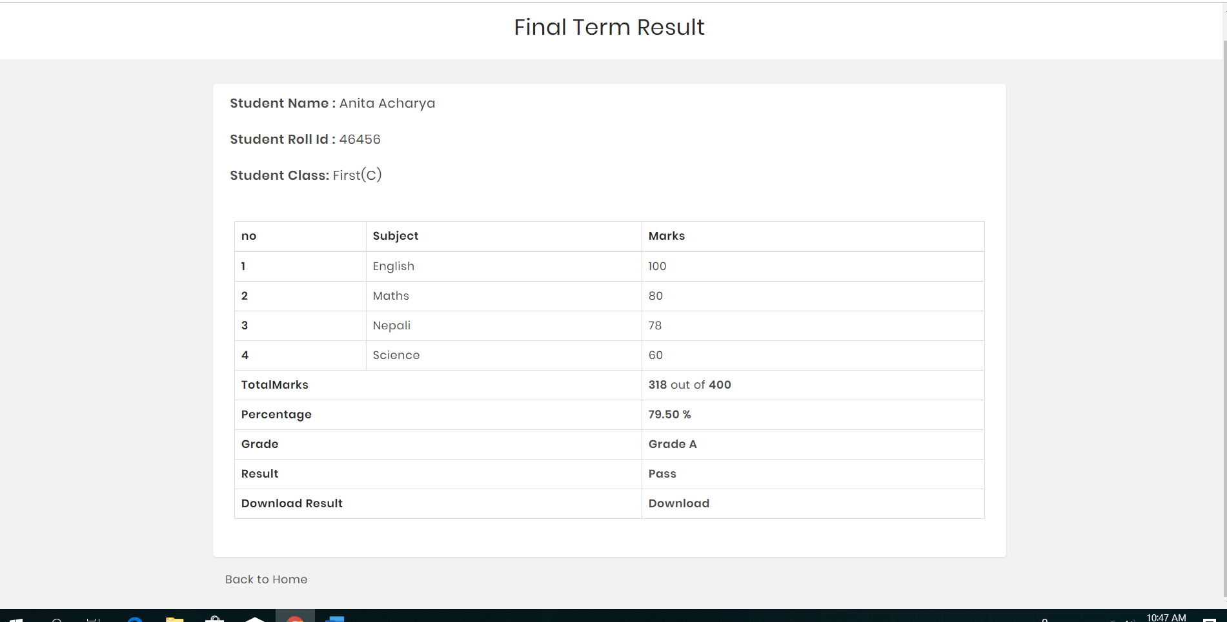

**Fig 5.13 Result Page**

The above screenshot shows the result page of our website. We can also download the result in pdf format.

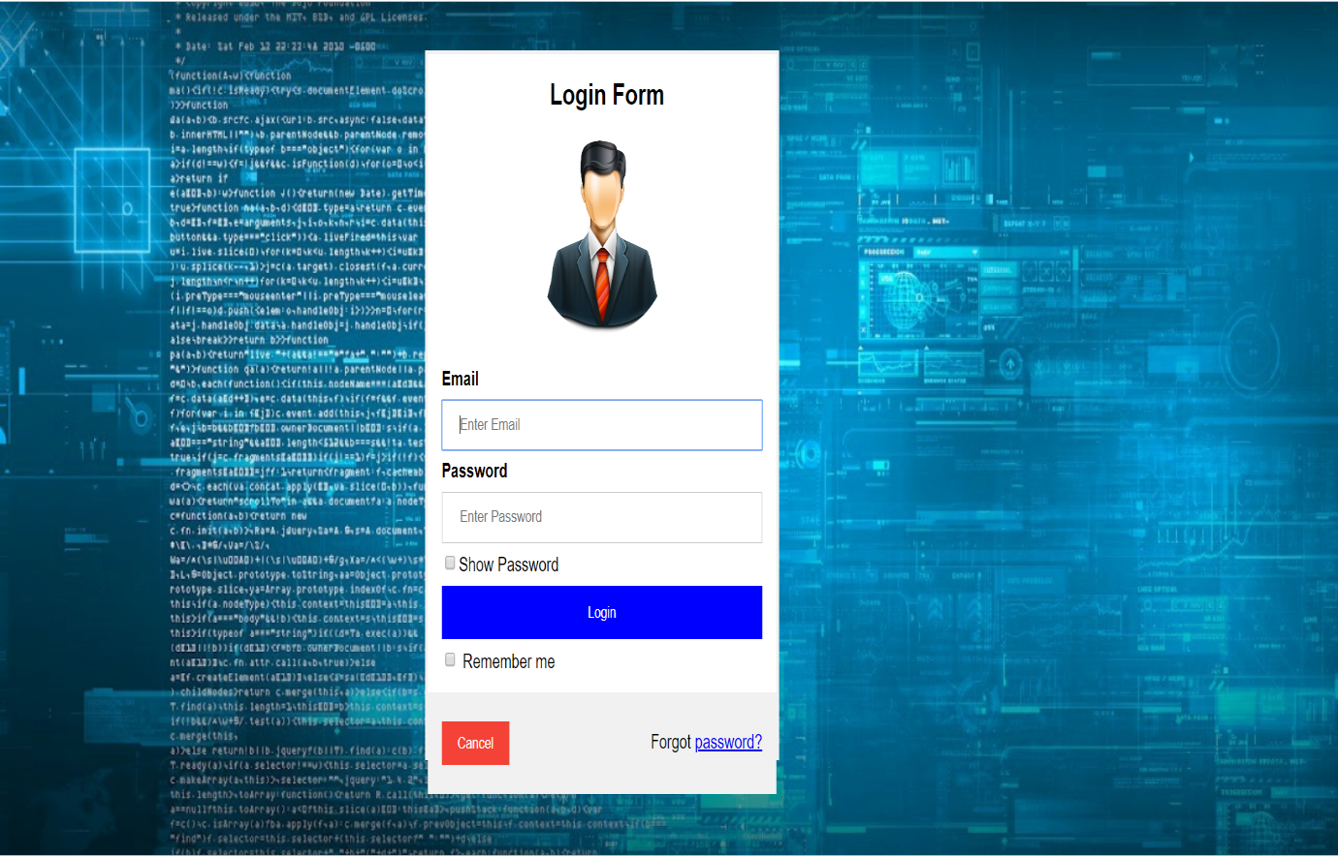

**Fig 5.14 User Login Page**

The above screenshot shows the login page for the website for students, teachers.

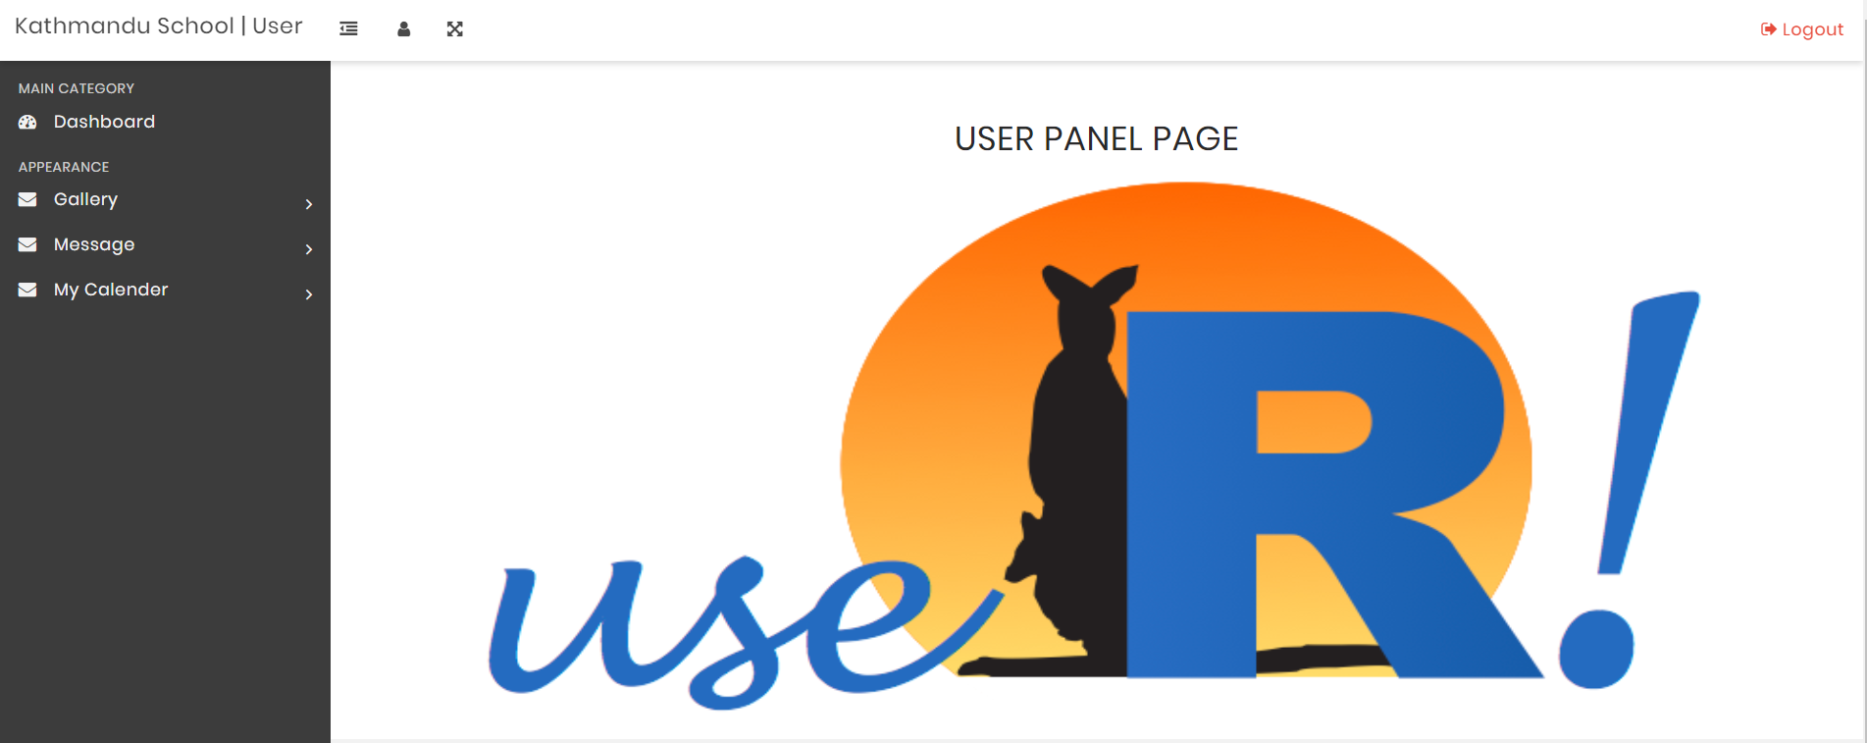

**Fig 5.15 User Panel Page**

The above screenshot shows the dashboard for user login page.

**CHAPTER 6**

**CONCLUSION AND RECOMMENDATION**

**6.1 Conclusion**

Hence, after the completion of this project we got more familiar with the front-end and back-end web technologies and its features. This project has been a good learning process through which we learnt web development in php and all the back-end stuff with it. At the same time, we have developed a deep understanding about the database management using MySQLi.

We still want to emphasize that the project is not complete by yet. There are still lots of room for improvement. A lot of bugs are still present and the code itself is not optimal. New features such as SMS notification can be added to it and the overall design can still be improved.

**6.2 Future Enhancement**

A complete website can only be developed with lot of intensive effort and time overtime. Due to being amateurs in programming projects like this and unable to solve the ensuing errors and lack of time management we couldn’t include everything that we had in mind with this project. Though it may pass as a website but it can be further enhanced to improve the user experience considering the following requirements:

1. Simplifying and improving the design structure and the code itself.
2. Features like SMS notification and download option for documents and result can be added for convenience

**REFERENCES**

1. “Khwopa Engineering College”, https://khec.edu.np/ [02/12/2018]
2. “XAMPP”, https://en.wikipedia.org/wiki/XAMPP/ [02/12/2018]
3. “GEMS School”, http://www.gems.edu.np/ [03/12/2018]
4. “Galaxy School” <http://www.galaxy.edu.np/> [27/12/2018]
5. “Lincoln School”, https://www.lsnepal.com/ [07/01/2019]
6. ”Little Angels School”, http://las.edu.np/ [11/01/2019]